

GFD-DPP
Application DesigN
Assuralia

 |  | 

Document control
Document revision history
Version | Date | Author | Comments
1.0 | 06/08/2013 | Architecture Team
1.2 | 09/08/2013 | Jos Van Dorpe | Review

Table of Content
Table of Content 2
List of Figures 4
List of Tables 5
1 Introduction 6
1.1 Objectives 6
1.2 Intended Audience 6
1.3 Scope 6
1.4 References 6
1.5 Assumptions 6
1.6 Definitions 6
2 Functional Summary 7
3 Connector Solution Overview 8
4 TIP Solution Overview 9
4.1 Flows 9
4.1.1 Register BVAC Data 9
4.1.2 Get BVAC Data 12
4.1.3 Get Configuration 16
4.1.4 Get Status 17
4.1.5 Send Status 17
4.2 Assuralia Table Status Flow 17
4.3 BVAC Reporting 18
4.4 Error List 18
4.5 Special Requirements 18
4.5.1 Non Functional Requirements 18
4.5.2 Performance Monitoring 18
4.5.3 Audit 18
4.5.4 Logging 18
4.5.5 Deletion 19
5 TIP Component Technical Details 21
5.1.1 TIP Router 21
5.1.2 BVAC_REPORT_FILTER 22
5.1.3 Get BVAC Message 23
5.1.4 Encrypt2 24
6 Message Data Formats 26
6.1 Register BVAC Data 26
6.1.1 Message Structure 27
6.1.2 Field definition 29
6.2 Get BVAC Data 29
6.3 Status Management 30
7 TIP Configuration 32
7.1 TIP System Configuration List 32
7.2 TIP Routing Rules 33
7.3 TIP Insurer Configuration 33
7.4 TIP Public Key Store 34

List of Figures
Figure 1 - Single Message and BVAC 24
Figure 2 - BVAC Event definition 25
Figure 3 - Get BVAC messages 27
Figure 4 - Status Message Entity 28

List of Tables
No table of figures entries found.

Introduction

Objectives
The objective of this document is to describe the technical design for the adaptation for Assuralia to the TIP system and connector module.

Intended Audience
Audience for this document is:
- Interface and ESB developers
- Client TSC
- Client support teams

Scope
The scope of the document is the design impact on the TIP for the new Assuralia service as well as a high level description of changes needed in the integration module.

References

Ref ID | Name | Version | Location
1 | GFD-DPP_Glossary | 0.0.2 | ACN Sharepoint:
2 | GFD-DPP_Application_Analysis | 0.2.1 | ACN Sharepoint:
3 | List Of GFD-DPP Error Definitions | 0.0.2 | ACN Sharepoint:
4 | Cookbook ETEE (known & unknown recipient) |  | https://wwwacc.ehealth.fgov.be/nl/support/basisdiensten/systeem-voor-end-end-vercijfering
5 | GFD-DPP_Application_Design_General | 0.1.0 | ACN Sharepoint:
6 | Drools documentation | 5.4.0 | http://docs.jboss.org/drools/release/5.4.0.Final/drools-expert-docs/html/ch02.html#d0e1157
7 | GFD-DPP_Application_Design_TIPSystem | 0.2.1 | ACN Sharepoint
8 | GFD-DPP_Application_Design_ConnectorModule | 0.2.2 | ACN Sharepoint

Assumptions

Ass ID | Description | Validation
1 | For the design, we assume that for the Assuralia flow will be an extension of the TIP system.
2 | We assume status messages will not be used by AssurCard or Insurers

Definitions

For definitions used in this document, please refer to glossary (see [Ref 1]).

Functional Summary

Next to the national compulsory health insurance (RIZIV-INAMI), a citizen has the possibility to contract complementary coverage for health related out-of-pocket costs with the insurer(s) of his choice.

Contrary to interventions by RIZIV for pharmaceutical products using a third party settlement process, the patient still has to advance the amount and claim reimbursement from his insurers in case of complementary insurance. To this means the pharmacist can issue a BVAC attestation clearly identifying the patient, the product(s) and the price among other things. The patient/insured person submits the BVAC to his insurer by post, handover or other permitted channels to obtain a (partial) reimbursement depending on the specifics of his contract.

As the personal share of medical expenses (portion of the cost not covered by INAMI) is increasing, patients are increasing their complementary coverage. At present an estimated 3 million BVAC attestations are issued yearly.
In the context of the Panoramix project, we will implement an Assuralia flow in the TIP that will automate the transfer of the information contained within the BVAC attestation from pharmacist to insurer enabling reimbursement to the patient/insured person. This will reduce the administrative load for
- the patient: no more manual intervention to claim reimbursement
- the insurer: reduced handling and recoding as structured information is transferred electronically.
This flow can be called by pharmacy software through connector module.
Remark that some insurers use AssurCard as an aggregator to interact with care providers, the TIP will thus transfer the BVAC attestations to AssurCard instead of directly to these respective insurers.

At present only the electronic transfer of the BVAC data from pharmacist to insurer is in scope.

Connector Solution Overview
The impact on the connector is limited to
- Support of extended single message (including BVAC event) for register data event
The register data function of the business connector is updated to support validation for the new XSD, thus including the BVAC event.
- Generation of unique BVAC document Id (25 numbers) to include in SMC BVAC event. This BVAC document id is returned to pharmacy software. Similar logic is applied as done for Dispensation GUID.
- Get System Configuration – CBFA number
The Get System Configuration call will now also contain a list of the supported CBFA numbers by TIP (cf. Get Configuration for TIP Solution). This list needs to be cached in memory of connector module.
In case a connector module is not yet upgraded to the latest version support new system configuration file, it will not fail but only skip the not yet known configuration fields in the system configuration file.
- Validation on CBFA number
The business connector function “register data” will include validation on CBFA number based on list retrieved in point 2. In case CBFA number is not supported by TIP, an error ‘Insurer not supported, CBFA number unknown’ is thrown to pharmacy software and an entry is made in local log.

In the latter case the pharmacist must tell to the patient to deliver the BVAC attest manually to the insurer as done nowadays.

- The offline component is not used for the BVAC event.
In case of BVAC event, then the “register data” function in the business connector will directly make a call to TIP without going through the offline component. In case the TIP cannot be reached (for any possible reason), then the message is discarded (with an entry in local log) and the pharmacy software retrieves an error stating TIP not available and BVAC attest cannot be delivered electronically.
In the latter case the pharmacist must tell to the patient to deliver the BVAC attest manually to the insurer as done nowadays.
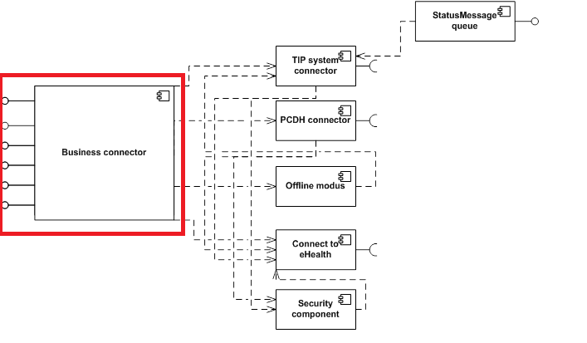

TIP Solution Overview

Flows
The Assuralia flow will be an extension on the TIP Single Message Concept, enabling:
- A variant of the existing TIP “Register Data” Flow to submit BVAC messages to the TIP, for routing to new endpoints
- A new webservice and SFTP service (both not passing through eHealth) to allow Insurers to pick up BVAC messages from TIP (whether independently or through an aggregator like Assurcard)
- A new configuration for CBFA numbers that can be used by connector module
- An adaptation of passing through status messages from AssurCard / Insurers to Connector Module to support BVAC document Id
All services pass through the TIP proxy for security checks (authentication & authorization of calling system to TIP service) as defined in TIP design.
Legend for colors used in diagrams in this chapter:
Components that contains specific logic for this main flow. Note that this does not exclude that some logic could be reused for other main flows.
Components that are common over flows and should be implemented in that way, thus shared and reusable.
Adapters that are offered by the technology and only require configuration.
Components that are not in implementation scope of this document or project.

Register BVAC Data

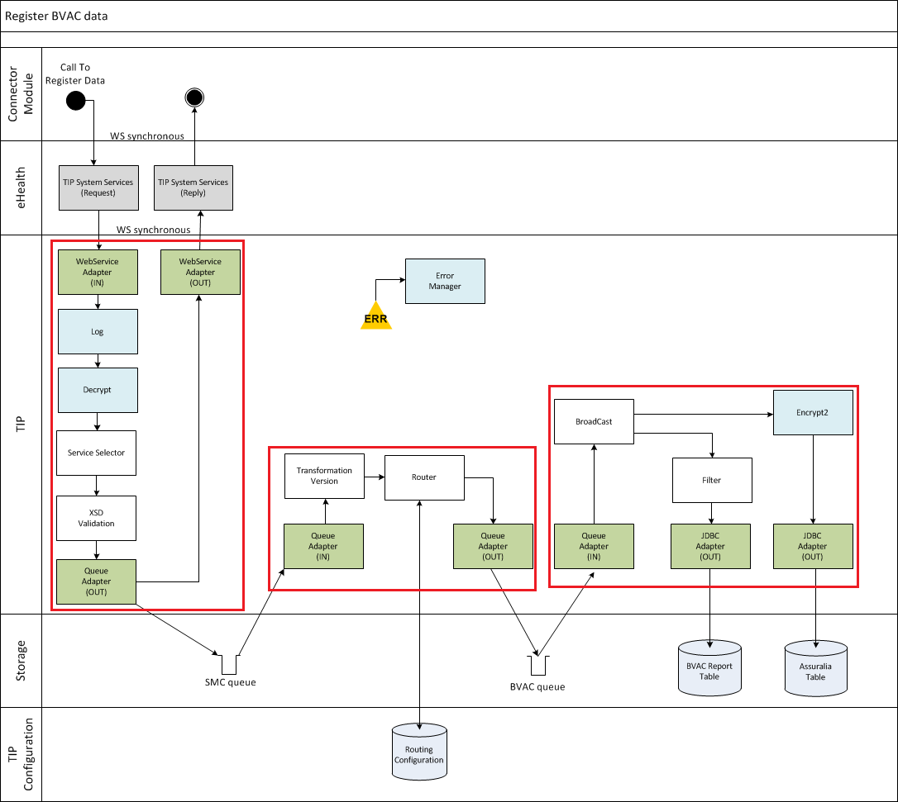

FLOW 1:
- The webservice adapter gets the message.
- A log entry is made for auditing purposes.
LOG(message) – cf. [7] Tip Application Design
- The request is decrypted for the TIP.
DECRYPT(message, <TIP>) – cf. [7] Tip Application Design
- The service selector component will check the “clear” header data and add a service tag “registerBVAC” to the message based on operation and event data-type = BVAC event.
SERVICE_SELECTOR(message) – cf. [7] Tip Application Design
- The request is validated against an XSD to assure all fields are well formatted and completed to be able to perform the registration for the specified data type. The XSD to validate against is chosen through the service-tag “registerBVAC”.
VALIDATE(message, <service-tag>) – cf. [7] Tip Application Design
- The message is stored on an internal SMC queue to ensure persistence. A response ‘ACK’ is generated and sent to the connector module if all went well till this point. We assume transport encryption is sufficient in this context for the ACK. From now on, the process continues in asynchronous mode.

FLOW 2:
- Messages are picked up from the SMC queue and processed.
- No timestamping is performed. This step is skipped (IF-clause) through the service tag.
- An optional transformation to the latest XSD version of the SMC is executed in case the calling connector module is not working on the latest XSD version on which the logic of TIP is built. This is based on XSLT transformation.
TRANSFORM_VERSION(message, <service-tag>) – cf. [7] Tip Application Design
- The message is routed and stored on the BVAC queue based on the service tag.
TIP_ROUTER(message)

FLOW 3:
- Messages are picked up from the BVAC queue and processed.
- A router (mule: ALL) will broadcast the flow two message processors
  - A: for storage in Assuralia Table
  - B: for reporting

- To Assuralia Table
            - The full BVAC Single message is encrypted with the public certificate of the insurer corresponding with the given CBFA number. Added to message in clear in XML are: Pharmacy ID, CBFA number and Document Id, so these can be stored in the Assuralia Table.

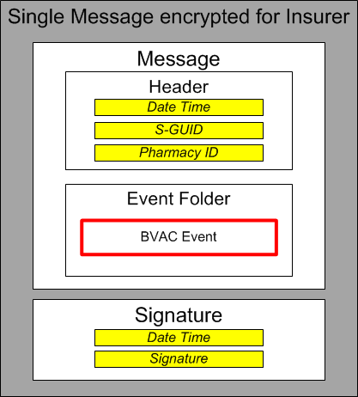

            - Message stored in Assuralia Table providing following fields:
              - Id : Oracle sequence
              - Pharmacy: pharmacy ID
              - CBFA: identifying insurer
              - DocId: BVAC document ID
              - BVACmessage: encrypted message content for insurer
              - ReceivedDate: current dateTime
              - Status: “New”
              - StatusDate: current dateTime
              - FileName: name of file in SFTP directory of CBFA

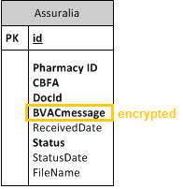

- BVAC Reporting
            - Filter (via cached XSL): only a selection of fields from the BVAC message should be stored for reporting:
              - CBFA number
              - Delivery Date
              - Birthdate
              - Product Type
              - Product Id
              - Full Product Description
              - Product Quantity
              - Public Price
              - Paid Price
              - Total Public Price
              - Total Paid Price
              - Total Homéopathie
The other fields should be removed from the XML.
BVAC_REPORT_FILTER(message)

            - Store file in BVAC reporting table
              - Id : Oracle sequence
              - BVACmessage: filtered message content

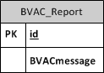

Get BVAC Data
The “Get BVAC DATA” service will allow Insurers to retrieve BVAC messages sent by pharmacies from the TIP system. The TIP will allow 2 mechanisms:

Through Web Service

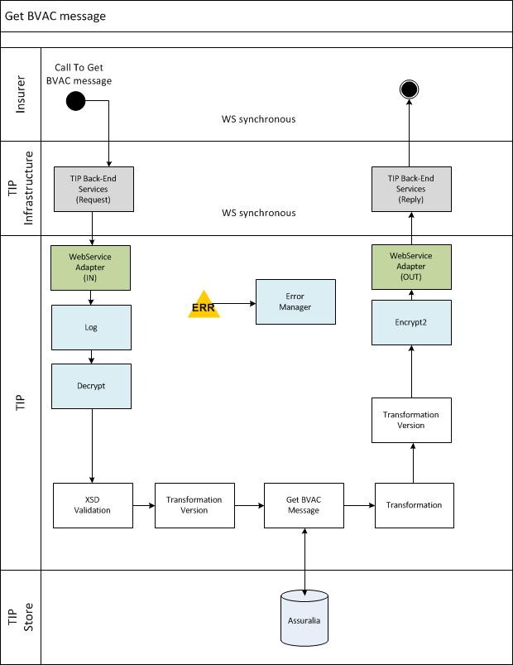

The Assuralia table is reachable through HTTPS for all authenticated insurers.

FLOW 1:
- The webservice adapter gets the “get BVAC” message (5.1.3). Note that the calling party is here already authenticated & authorized to make this call via the TIP proxy.
- A log entry is made for auditing purposes to indicate that AssurCard / Van Breda / … or Insurer put a request for BVAC messages.
LOG(message) – cf. [7] Tip Application Design
- The request is decrypted for the TIP.
DECRYPT(message, <TIP>) – cf. [7] Tip Application Design
Note that the Insurer should have the TIP public key on its server to be able to encrypt the message. When the TIP public key is updated, the insurers should receive the updated version (manual intervention).
- The request is validated against an XSD to assure all fields are well formatted and completed to be able to perform the “get BVAC messages” request.
VALIDATE(message, <service-tag>) – cf. [7] Tip Application Design
As only one type of operation ‘getBVACMessage’ is supported in this flow, no specific logic need to be applied to retrieve the service tag; It can be directly filled in this step. The service tag equals the WSDL operation value.
The signature of the requestor is also checked to ensure integrity of the request and validate public key.
- An optional transformation to the latest XSD version is executed in case the insurer is not working on the latest XSD version on which the logic of TIP is built.
TRANSFORM_VERSION(message, <service-tag>) – cf. [7] Tip Application Design
- All the available (‘New’) BVAC messages are retrieved from the Assuralia table based on the CBFA number in the request.
GET_BVAC(message).
A calling party can only pick up the BVAC messages to which it is authorized. This is checked through the 7.3 TIP Insurer configuration and public key (validated in 4). If not an insurer (no CBFA number), the TIP will check if the calling party is available in the party list for the CBFA in the TIP Insurer Configuration, based on public key id, and as such is authorized to pick up the BVAC messages.
- The aggregated BVAC messages are put in a right formatted response message.
TRANSFORM(message, XSL file) – cf. [7] Tip Application Design
The XSL file is optional depending on build.
- An optional transformation occurs on the response from the latest XSD version to the XSD version of the calling insurer.
TRANSFORM_VERSION(message, <service-tag>) – cf. [7] Tip Application Design
- The FULL response is encrypted for the targeting insurer / AssurCard / … with the proper public certificate.
ENCRYPT2(message, <CBFA/Party-ID>)
Note that the encryption is not using eHealth, but will be a local encryption using the public key of the requestor (AssurCard, Van Breda, Insurer, ..) that is stored on the TIP.
- The response is returned to the insurer. A log entry is made in audit table to indicate that BVAC messages have been sent to CBFA.

Through SFTP

1. BVAC EXTRACT BATCH
The TIP system will have a nightly “BVAC extract” batch that will extract all data from the Assuralia Table for every insurer that is configured with end-point-type = SFTP (cf. 7.3 TIP Insurer Configuration).

The batch will perform following actions:

Load TIP Insurer Configuration

Loop for every CBFA where end-point-type = SFTP
<list of (id, BVAC Message)> = SELECT id, BVACmessage FROM ASSURALIA WHERE Status=’New’
Aggregrate <list of BVAC Message> list into single file (cf. below) with filename BVAC-<CBFA>-<date>.xml
Store file in SFTP directory for CBFA (from configuration)
UPDATE ASSURALIA SET Status=’File’, StatusDate=sysdate, Filename=’BVAC-<CBFA>-<date>.xml’ WHERE id IN <list of ids>
End Loop

The file can then be picked up by an insurer through SFTP connection. Each insurer has its dedicated directory, cf. 7.3 TIP Insurer configuration.

The access to the SFTP directories are configured on infrastructure to be only accessible by the authenticated insurer by verifying public key. The SSH public key (2048 bits) of the insurer is stored on TIP. The public/private key pair needs to be renewed every 3 years between TIP and Insurer through manual agreement between APB (Farmaflux) and Insurer (or AssurCard).
The TIP SFTP setup will associate the user name of the insurer with the public SSH Key, so there is no need to each time enter a password. The data is transferred from TIP to Insurer through a secure channel (SSH-2) with data encryption based on a temporary agreed symmetric session key based on AES-192 algorithm.

The file format is XML and looks like:
<bvac-list>
<CBFA>0196</CBFA>
<bvac>
<bvac-document-id>12345687987654321</bvac-document-id>
<bvac-document>
<!—ENCRYPTED (for Insurer corresponding with CBFA) message structure as defined in 5.1.1
-->
</bvac-document>
</bvac >
<bvac >
<bvac-document-id>12345687987654322</bvac-document-id>
<bvac-document>
<!-- ENCRYPTED (for Insurer corresponding with CBFA) message structure as defined in 5.1.1
-->
</bvac-document>
</bvac >
…
</bvac-list>

2. BVAC FILE CHECK
The TIP system will have a nightly “file check” batch scheduled before the BVAC extract batch that will check if the BVAC file(s) are picked up by the Insurer. If the file(s) is picked up, we update the status of the respectively BVAC documents in the Assuralia Table to “Sent” to indicate in the table that the BVAC documents are handed over to the insurers.

The batch will perform following actions:

Load TIP Insurer Configuration

<list of CBFA> = SELECT DISTINCT CBFA FROM ASSURALIA WHERE FileName IS NOT NULL

Loop for every CBFA in <list of CBFA>
<list of FileName>= SELECT DISTINCT FileName FROM ASSURALIA WHERE CBFA =’ <CBFA>’ AND Status = ‘File’
Loop for every FileName
Check if File with FileName is present in SFTP directory of CBFA
IF NOT
UPDATE ASSURALIA SET Status=’Sent’,StatusDate=sysdate where FileName = ‘<FileName>’
ELSE
Do Nothing.
END IF
End Loop
End Loop

3. BVAC DELETION
The deletion batch will remove the BVAC messages that have been sent to insurer from Assuralia table or which are stored for long time in the Assuralia table. Cf. 4.4.5 Deletion Batch for more details.

Insurer switch from SFTP to Web Service
An insurer can only start calling the Get BVAC web service when the TIP insurer configuration is adapted in the TIP by APB. As long as APB does not confirm the configuration change, the insurer will need to keep doing SFTP.

When an insurer switches from SFTP to Web Service, it can occur that there are still files present in the SFTP directory of the insurer. In this case it’s up to the insurer to retrieve these files before they are deleted by the nightly deletion batch (cf. 4.4.5). Once a file has been created, it is no longer possible to retrieve the contained BVAC records by web service.

Get Configuration
There is no technical change compared to the TIP design for this service, but a new type of configuration will be made available from TIP to connector module:
CBFA numbers
The connector module will validate the CBFA number in the single message BVAC event provided by the pharmacy software. Only CBFA numbers that are available in the connector configuration will be accepted, otherwise an exception ‘invalid CBFA number’ is thrown.
The CBFA list in the connector module is provided by the TIP system as part of the existing “Get Configuration” service (existing TIP System Configuration). It contains a list of CBFA numbers of insurers that are supported by the TIP:
CBFA number
0739
0079
0196
0014
0037
0097
Xxxx

For the proper XML format, please refer to paragraph 7.1 TIP System Configuration List.
The TIP Insurer Configuration is manually uploaded by the TIP configuration manager into the TIP system, and contains the CBFA list.
For the connector, the CBFA list is requested to TIP on a daily basis at the start of the day, when the single sign-on session is started. It is part of the same ‘full’ system configuration message sent by TIP with TIP connection parameters during start-up.

Get Status
No technical change required compared to TIP design (ref 7) but new type of status messages (BVAC event) are made available to connector module.

The Get Status service as described in TIP design (ref [7]) is used by connector module to collect TIP status messages on the BVAC delivery sent by the insurers. The pharmacy ID is used to identify all needed status messages on TIP.

The TIP will provide status messages on 2 moments to pharmacy for a BVAC event:
- When the BVAC event message arrives on TIP (synchronous reply)
- When the BVAC event message is picked up by Insurer or other party (e.g. AssurCard) (cf. 4.5.5 deletion batch)

Send Status
Send Status for BVAC event is not supported by Assuralia – not in scope of CR

Assuralia Table Status Flow

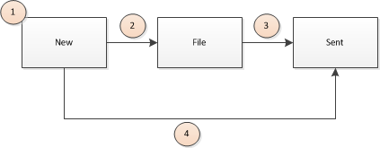

The BVAC messages go through specific statuses in the Assuralia table in the TIP:
- When a BVAC message arrives in the TIP, is processed and is ready for sending to insurer, it is stored in the Assuralia table with status “New”.
- Only for SFTP: when a BVAC message is picked up by the “extract batch” (4.1.2.2) and is stored in a file for SFTP sending to insurer, the status of the BVAC message is changed in the Assuralia table to “File”
- Only for SFTP: when the file is picked by the insurer, the status of the contained BVAC messages is changed in the Assuralia table to “Sent”
- Only for Web Service: when the insurer or AssurCard called the web service ‘Get BVAC messages’ and as such picked up the BVAC messages from the Assuralia table, the status of the picked up BVAC messages is changed from “New” directly to “Sent” in the Assuralia table.

BVAC Reporting

Specific (filtered) content of the BVAC message is extracted for reporting purposes and stored in the BVAC_Report table. (cf. 4.1.1 register bvac data flow)

A daily batch executed during the night will extract all data from this table and put this in a file in a dedicated SFTP directory. The format of the file is:
<BVAC-Report>
<BVAC-message> content of BVAC event cf. message format Figure 2</BVAC-message>
<BVAC-message> </BVAC-message>
…
</BVAC-Report>
Once successfully extracted, the table is cleared.
A TIP administrator responsible for BVAC reporting can pick up the file then from the directory via SFTP.

Error List
For errors used in this document, please refer to error list (cf. Ref [5]).

Special Requirements

Non Functional Requirements
Cf. TIP Application Design [7].
The Pharmacist need to know immediately the TIP status on the BVAC message to provide correct feedback on the patient of the usage of his/her BVAC attest. As such a response to flow 1 of register BVAC data should be available within 2 seconds to connector module (excl. eHealth).
In case the TIP is offline, then there is no offline queueing in connector module and the BVAC message is discarded. In this case, the pharmacist will tell to patient to use the paper BVAC attest and to submit it to the insurer.

Performance Monitoring
Cf. TIP Application Design [7].

Audit
Cf. TIP Application Design [7]..

Logging
Cf. TIP Application Design [7].
The standard logging as for current TIP application is also applied for the BVAC flows.
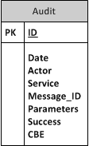

Deletion
A TIP “BVAC deletion” daily batch will clean every night the Assuralia table Cf. 3.1.2.2 Get BVAC Data – through SFTP.
The deletion batch will also create status messages (cf. Figure 4 - Status Message Entity, aligned with current TIP implementation of status messages, but addition of BVAC Document ID) to pharmacy for the actions performed: BVAC message picked up or not picked up by insurer and store these in the pharmacy feedback table.
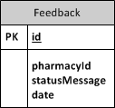
It is scheduled after the BVAC Extract Batch.
The batch will perform following actions:

Load TIP Insurer Configuration
Load TIP Global Configuration

/*--- sent --- */
SELECT DISTINCT < PharmacyId, CBFA, DocId> FROM ASSURALIA WHERE Status = ‘Sent’
LOOP for every DocId
statusMessage = Create StatusMessage(PharmacyId, CBFA, DocId, Success)
INSERT INTO Feedback VALUES (seq_id, Pharmacy_Id, statusMessage, date)
END LOOP

SELECT DISTINCT <CBFA,FileName> FROM ASSURALIA WHERE Status = ‘Sent’
LOOP for every FileName
delete FileName from SFTP directory of associated CBFA
END LOOP
DELETE FROM ASSURALIA WHERE Status = ‘Sent’
> Log output of deletion in Log File & Audit table, thus listing which records where deleted (including CBFA & BVAC document Id)

/*--- file --- */
SELECT DISTINCT < PharmacyId, CBFA, DocId> FROM ASSURALIA WHERE Status = ‘File’ AND StatusDate < (sysdate – [X])
LOOP for every DocId
statusMessage = Create StatusMessage(PharmacyId, CBFA, DocId, Error)
INSERT INTO Feedback VALUES (seq_id, Pharmacy_Id, statusMessage, date)
END LOOP

SELECT DISTINCT <CBFA,FileName> FROM ASSURALIA WHERE Status = ‘File’ AND StatusDate < (sysdate – [X])
LOOP for every FileName
delete FileName from SFTP directory of associated CBFA
END LOOP
DELETE FROM ASSURALIA WHERE Status = ‘File’ AND StatusDate < (sysdate – [X]) AND FileName in <list of FileName that were deleted successfully>
> Log output of deletion in Log File & Audit table, thus listing which records where deleted (including CBFA & BVAC document Id)

/*--- new --- */
SELECT DISTINCT < PharmacyId, CBFA, DocId> FROM ASSURALIA WHERE Status = ‘New’ AND StatusDate < (sysdate – [Y])
LOOP for every DocId
statusMessage = Create StatusMessage(PharmacyId, CBFA, DocId, Error)
INSERT INTO Feedback VALUES (seq_id, Pharmacy_Id, statusMessage, date)
END LOOP

DELETE FROM ASSURALIA WHERE Status = ‘New’ AND StatusDate < (sysdate – [Y])
> Log output of deletion in Log File & Audit table, thus listing which records where deleted (including CBFA & BVAC document Id)

With
- [X] = 14 days, but can be configured with parameter BVAC_FILE_RETENTION in TIP global configuration
- [Y] = 14 days, but can be configured with parameter BVAC_MESSAGE_RETENTION in TIP global configuration

TIP Component Technical Details
This paragraph contains components that are used across the flows that were listed in previous section. We’ve only listed the modules that are changed compared to TIP application design [7].

TIP Router
The TIP router determines through the header with routing parameters, on which queue the incoming message should be stored.

Logical processing

Input
XML message
with ‘body’ > ‘routing parameters’ > ‘TIP id’

Treatment
            - Get TIP id and (optional) Insurer from message
                - If empty TIP id, throw error TIP-3000
            - Lookup for destination in cache (TIP Routing Rules) to which queue, the message should be routed.
                - If destination not found in cache, throw error TIP-3001
            - Route message to correct target queue

Output
XML message on correct queue
Technical Note: a possible combined implementation of the 3 steps is through a ‘choice’ flow controller, cf. TIP configuration
Remark for Assuralia:
For Assuralia, the TIP router will route to the BVAC queue if a BVAC Event is present in the Single message.

Configuration
XML with TIP routing configuration (cf. chapter 7.2 on TIP configuration – TIP Routing Rules)

Component Summary
Property | Value
Component Name | TIP router
Component ID | 11
Component Type | Router Flow - choice
Component Consumer | TIP
Security | NA
Input Data | XML message
Output Data | XML message
Errors/Acknowledgement | TIP-403001
Data Sources | NA

BVAC_REPORT_FILTER
The BVAC report filter will filter the Single Message BVAC to only keep the fields that are interesting for reporting.

Logical processing

Input
XML message

Treatment
Select from BVAC input message following fields:
              - CBFA number
              - Delivery Date
              - Birthdate
              - Product Type
              - Product Id
              - Full Product Description
              - Product Quantity
              - Public Price
              - Paid Price
              - Total Public Price
              - Total Paid Price
              - Total Homéopathie
and filter out the remaining fields from XML.

Output
Filtered XML message

Configuration
XSL that defines filter for BVAC reporting

Component Summary
Property | Value
Component Name | BVAC_REPORT_FILTER
Component ID
Component Type | FILTER
Component Consumer | TIP
Security | NA
Input Data | XML message
Output Data | XML message
Errors/Acknowledgement | TIP-404000, TIP-404001
Data Sources | NA

Get BVAC Message
The Get BVAC message will pick up messages (based on CBFA) from the Assuralia Table to be sent to Insurer.

Logical processing

Input
XML BVAC request

Treatment
- Get CBFA number from request & optional BVAC document Id
- Lookup BVAC messages in Assuralia table with CBFA number & optional BVAC document Id & Status = “Ready_For_send:
IF DocId not empty
SELECT BVACmessage FROM ASSURALIA WHERE CBFA = “<X>” AND STATUS = “NEW” AND DocId = “<Y>”

ELSE
SELECT BVACmessage FROM ASSURALIA WHERE CBFA = “<X>” AND STATUS = “NEW”

with
<X> equal to CBFA number of authenticated requestor.
<Y> equal to (optional) BVAC document Id

- Embed all returned BVAC messages as response in XML message
- Update the statuses of all BVAC messages that are picked up to “SENT”. (= second JDBC call)
UPDATE ASSURALIA SET STATUS = “SENT”, STATUSDATE=”<current timestamp>” WHERE CBFA = “<X>” AND DocId IN (<Z>)

With
<Z> = list of BVAC document Ids that are embedded in XML message (step 3)

Output
XML BVAC Message

Configuration
Assuralia Table:
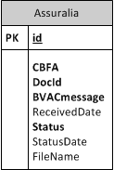

Component Summary
Property | Value
Component Name | Get BVAC Message
Component ID
Component Type | Data Access
Component Consumer | TIP
Security | NA
Input Data | BVAC Request XML
Output Data | BVAC message(s)
Errors/Acknowledgement | TIP-409004
Data Sources | NA

Encrypt2
The TIP should encrypt the BVAC messages for the Insurer or calling party.

Logical processing

Input
Clear XML message: this can be single message or full message depending on where the encryption module is called.
Key ID

Treatment
- Get Public Key based on key ID via TIP Public Key Store 7.4.
- Encrypt message with Public Key using SEAL API

Output
Encrypted XML Message

Configuration
Public key of Insurer / AssurCard / … in TIP Public Key Store 7.4.

Component Summary
Property | Value
Component Name | Encrypt2
Component ID
Component Type | Custom Component
Component Consumer | TIP
Security | NA
Input Data | Encrypted XML
Output Data | Clear XML
Errors/Acknowledgement | TIP-409011
Data Sources | NA

Message Data Formats
The following sections handle the fields and entities of the message in the scope of Assuralia.
We distinguish three types of messages that will be used in this context:
- Register BVAC event
- Get BAC event
- Status Message
Other TIP message formats are already described in the analysis document (Ref [2]) and TIP design (Ref [7]) and won’t be recapped here again.
In the diagrams below, the graphical conventions are:
- yellow for a data field;
- white blocks indicate composite elements;
- striped blocks are optional fields not filled in the shown exchanged message.

Register BVAC Data
The vehicle for sending Assuralia data is the BVAC document. The BVAC document will be part of the Single Message and will be contained in a new event type “BVAC Event” for the TIP system. Within one single message there will be only one BVAC document for one pharmacy.

Message Structure
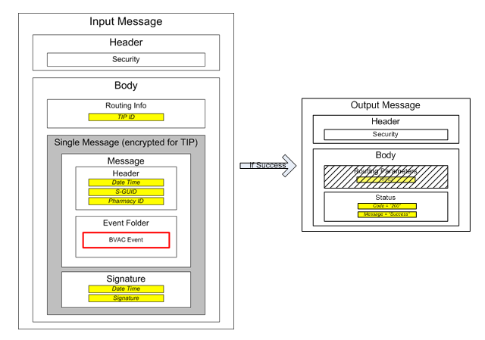
Figure 1 - Single Message and BVAC
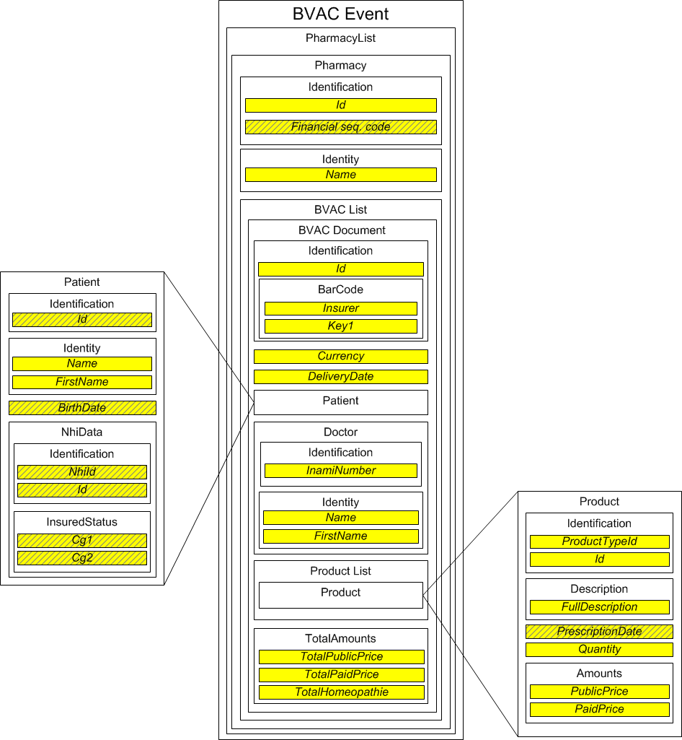
Figure 2 - BVAC Event definition

Refer to the XML schema definition and associated documentation for a technical description of all fields and elements.

Field definition

Referenced document for more details:

Get BVAC Data

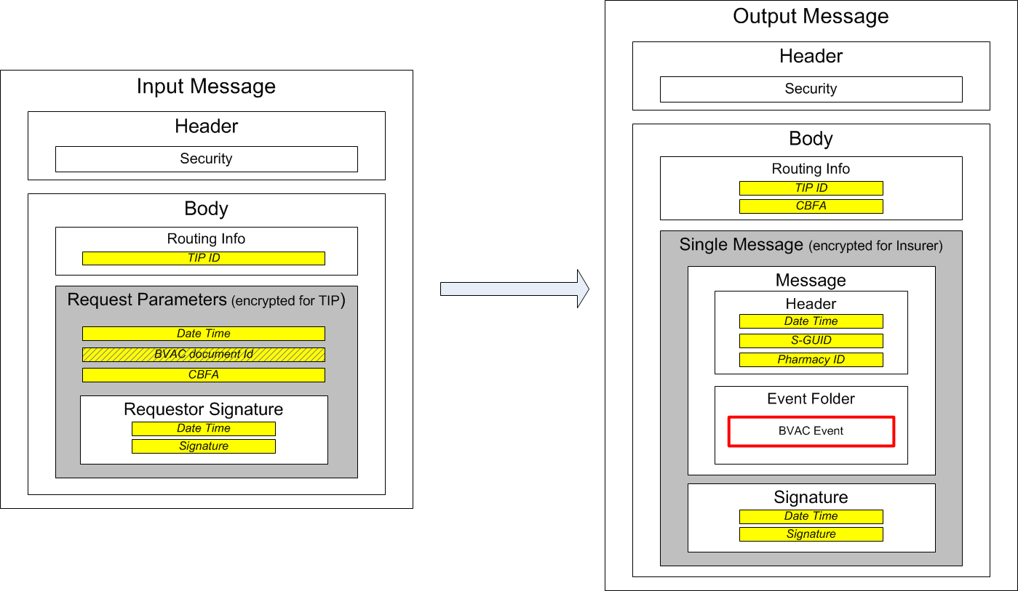
Figure 3 - Get BVAC messages

Status Management
The Status Message Entity is adapted for Assuralia to:
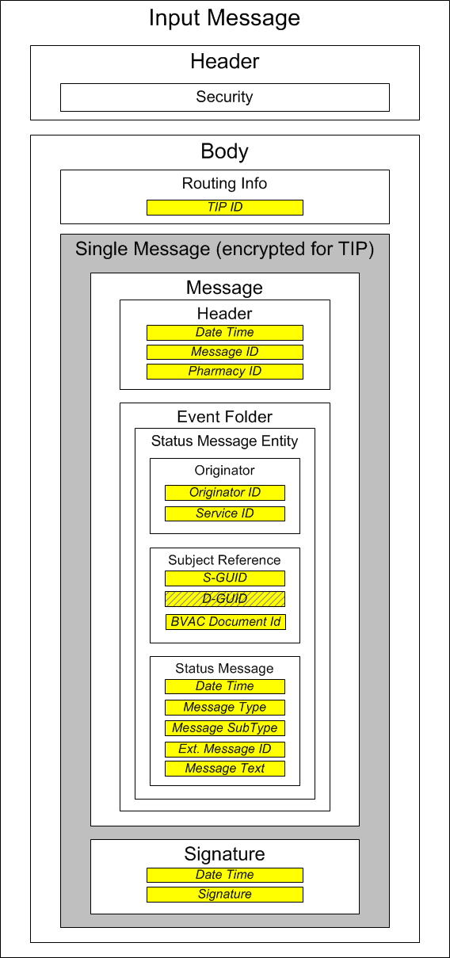
Figure 4 - Status Message Entity

A new OPTIONAL Subject Reference field is added, being the BVAC document Id. The BVAC document id is the unique identifier for the BVAC document.

TIP Configuration
This section contains all impacts on the TIP configuration for Assuralia.

TIP System Configuration List
Configuration Details

Type of file | XML
Directory | /config/
File name | conn-party.cfg

Description
The TIP System Configuration List is an XML containing various configurations related to systems to which the connector module can connect. It contains e.g. system IDs, URL of webservices for systems, .. For Assuralia, we add an optional contract list for a system (here TIP) to provide a list of parties (CBFAs of insurers) that participate to a specific contract (here BVAC). This CBFA list will be used by connector module to validate that TIP supports interaction with insurer for BVAC.
It has following format: (illustrative!)
<?xml version="1.0" encoding="UTF-8"?>
<p:systemServices xmlns:p="http://services.gfddpp.be/systemservices/v1" xmlns:xsi="http://www.w3.org/2001/XMLSchema-instance" xsi:schemaLocation="http://services.gfddpp.be/systemservices/v1 system-services-v20130708.xsd ">
<version>2013-07-01T12:00:00</version>
<systemServicesList>
<systemServicesEntry>
<system>
<systemType>TIP</systemType>
<systemId>0406753266</systemId>
</system>
<service>
<serviceName>TIPService</serviceName>
<URI>https://services-acpt.ehealth.fgov.be/GFDDPP/TIP/v1</URI>
</service>
<contractList>
<contractEntry>
<contractType>BVAC</contractType>
<contractPartyList>
<contractPartyEntry>
<contractPartyType>DKV</contractPartyType>
<contractPartyID>0739</contractPartyID>
</contractPartyEntry>
<contractPartyEntry>
<contractPartyType>Ethias</contractPartyType>
<contractPartyID>0196</contractPartyID>
</contractPartyEntry>
</contractEntry>
</contractList>
</systemServicesEntry>
<systemServicesEntry>
<system>
<systemType>PCDH</systemType>
<systemId>0406753266</systemId>
</system>
<service>
<serviceName>PCDHService</serviceName>
<URI>https://services-acpt.ehealth.fgov.be/GFDDPP/PCDH/v1</URI>
</service>
</systemServicesEntry>
</systemServicesList>
</p:systemServices>

TIP Routing Rules
Configuration Details

Type of file | XML
Directory | /config/
File name | tip-routing.cfg

Description
The rules to route message to a specific queue are gathered in a XML file with “TIP ID” to “queue alias” mapping.
It has following format: (illustrative!)
<choice>
<when expression="/element/@SERVICE = 'registerBVAC'" evaluator="xpath">
<jms:outbound-endpoint queue="BVACQueue"/>
</when>
<when expression="/element/@TIPID = 'TIP1'" evaluator="xpath">
<jms:outbound-endpoint queue="TIP1Queue"/>
</when>
<when expression="/element/@TIPID = 'TIP2'" evaluator="xpath">
<jms:outbound-endpoint queue="TIP2Queue"/>
</when>
<otherwise>
<jms:outbound-endpoint queue="TIPQueue"/>
</otherwise>
</choice>
This can be embedded in a flow as we don’t expect adaptations on-the-fly to the TIP routing configuration once TIP is running in production. The configuration adaptation requires a release. TIP routing configuration is “cached” in TIP for performance reasons.
Notes for Assuralia:
- If the service-tag is equal to “registerBVAC”, then route to BVAC queue

TIP Insurer Configuration
Configuration Details

Type of file | XML
Directory | /config/
File name | insurer.cfg

Description
The insurer configuration file is an XML containing a mapping between an insurer, end-point and parties that may act in name of insurer. It allows the TIP to put the BVAC message on the right end-point and provide access to the right party.
The configuration file is cached in the TIP during start-up.
It has following format: (illustrative!)
<tip-insurer-cfg>
<insurer>
<name>DKV</name> <!—name of insurer -->
<CBFA>0739</CBFA> <!— CBFA number : 4 numbers -->
<end-point-type>SFTP</end-point-type> <!—type of endpoint HTTPS or SFTP -->
<end-point>/assuralia/out/DKV/</end-point> <!—endpoint location -->
<key-id></key-id> <-- id for public key or certificate -->
<parties/> <-- list of parties that may act in name of insurer -->
</insurer>
<insurer>
<name>Ethias</name>
<CBFA>0196</CBFA>
<end-point-type>HTTPS</end-point-type>
<end-point/>
<key-id></key-id>
<parties>
<party>
<name>AssurCard</name>
<key-id></key-id>
</party>
</parties>
</insurer>
…
</tip-insurer-cfg >

Remark:
This configuration file is also used by the connector module to validate if the TIP supports the BVAC message that is provided by the pharmacy software. Only the mapping between the insurer name and the CBFA number is however transmitted to connector module. Please refer to 7.1 TIP Connection Parameters.

TIP Public Key Store
The TIP will have a repository that maps <key-id>s from configuration 7.3 with public key ids.

